**Name**:Sabah Hossam Eldeen Mostafa Mohamed

**B.N/**396

**Date**: 6-6-2021

**Topic**: Internet Of Things

**Application Brief**: I chose this topic because its applications are the most used in the world

**GitHub-Link:**

**GitHub-Page(Published Website):**

**Screenshots**:

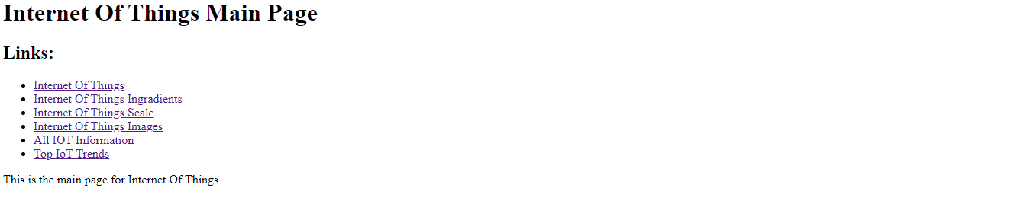

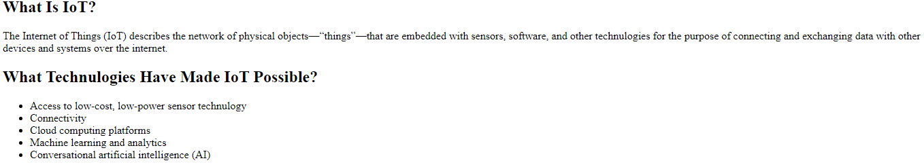

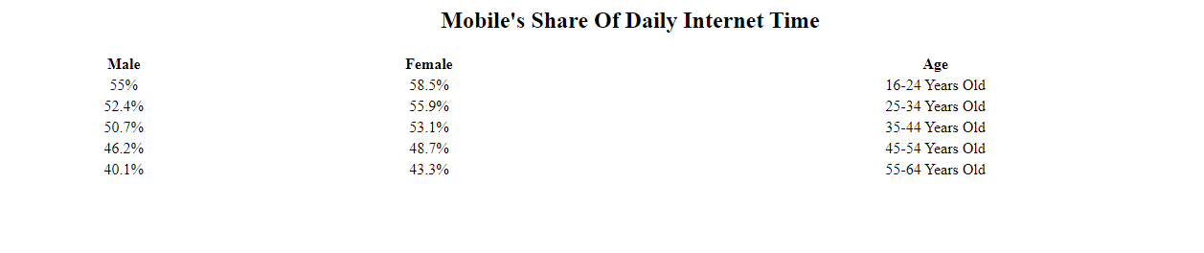

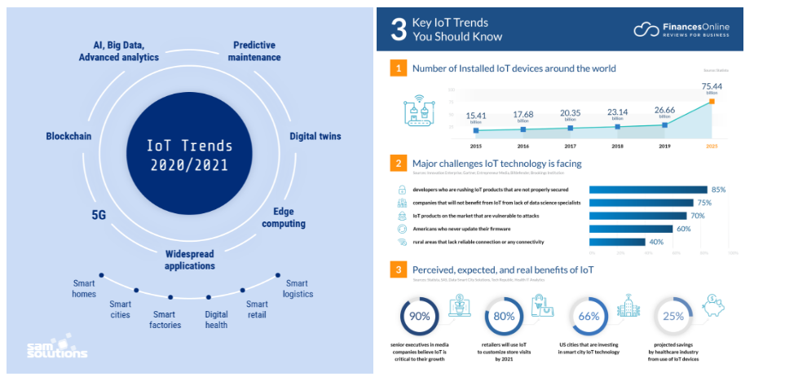

**Source Code**:

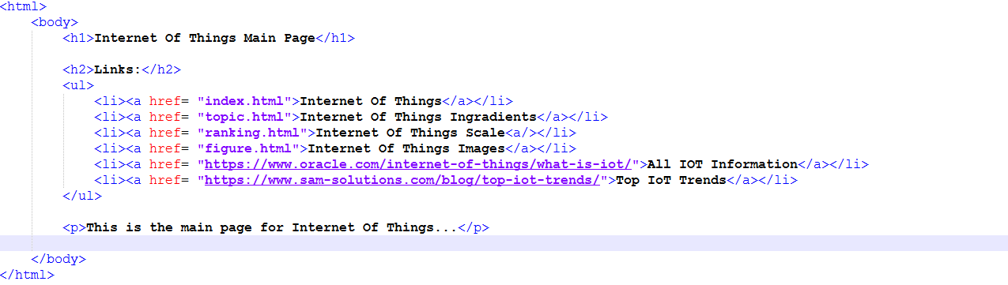

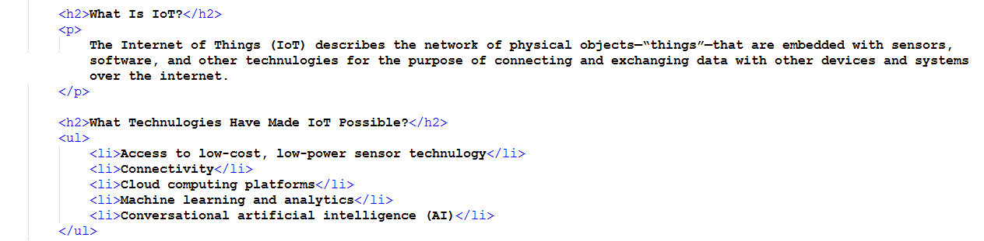

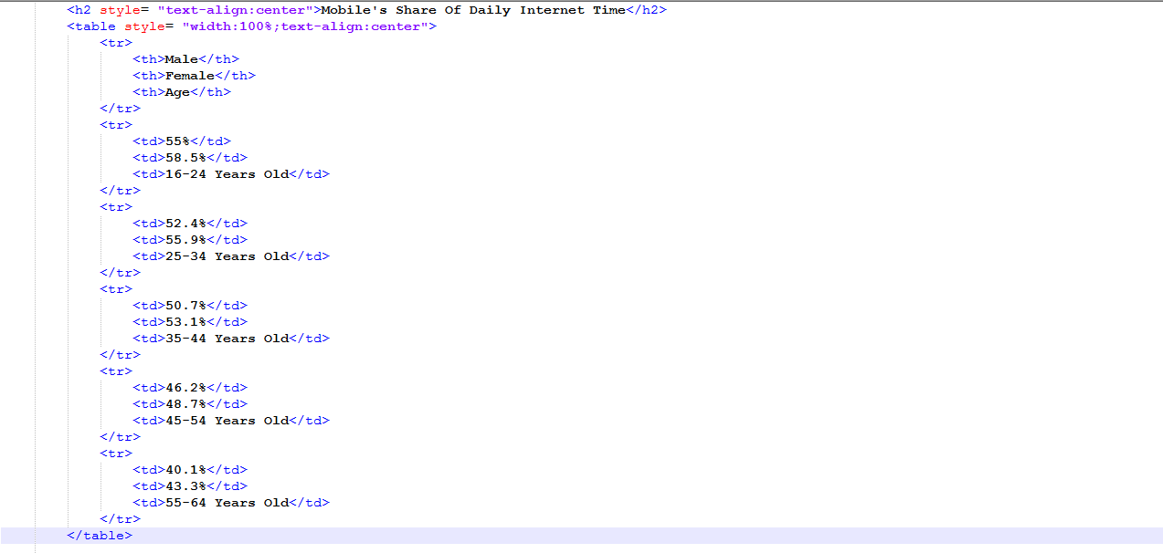

8